Exercise 1
1. Write the complete SQL statement for creating a new database called address book
CREATE DATABASE addressbook;
USE addressbook;
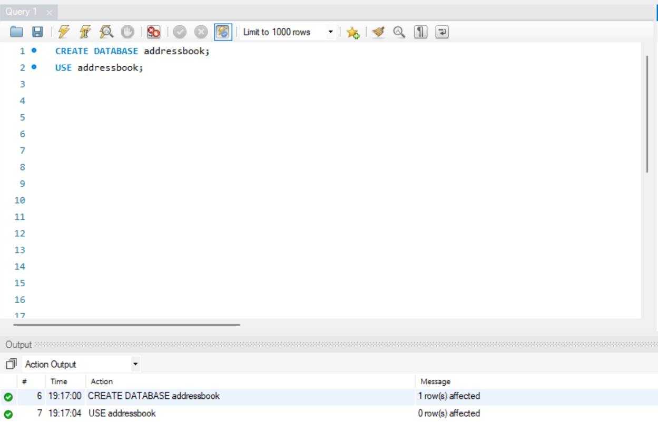
2. Which statement is used to list the information about a table? How do you use this statement?
CREATE TABLE employee_data (
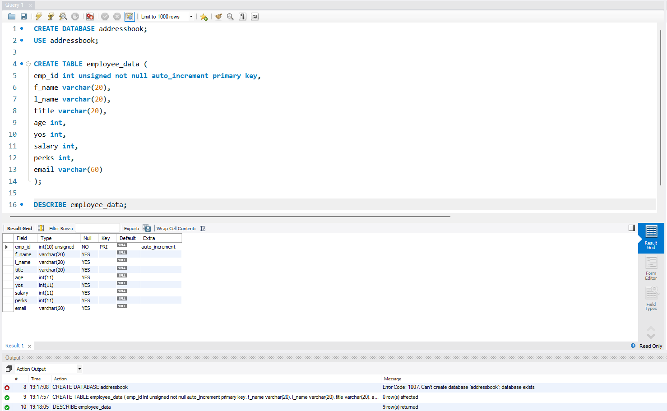
emp_id int unsigned not null auto_increment primary key,
f_name varchar(20),
l_name varchar(20),
title varchar(20),
age int,
yos int,
salary int,
perks int,
email varchar(60)
);

DESCRIBE employee_data;
3. How would you list all the databases available on the system?
SHOW DATABASES;
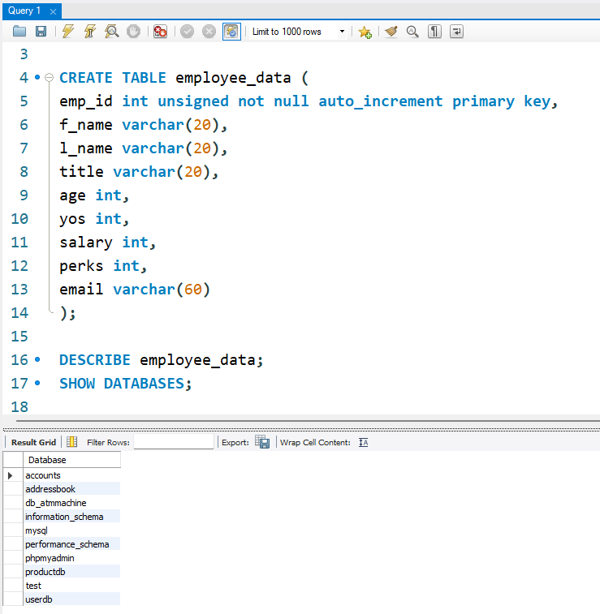
4. Write the statement for inserting the following data in employee_data table?
INSERT INTO employee_data
(f_name, l_name, title, age, yos, salary, perks, email)
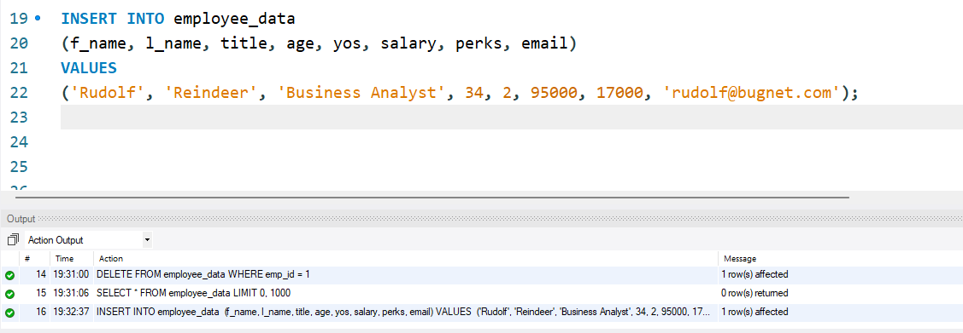
VALUES ('Rudolf', 'Reindeer', 'Business Analyst', 34, 2, 95000, 17000, 'rudolf@bugnet.com');

5. Give two forms of the SELECT statement that will list all the data in employee_data table?
SELECT * FROM employee_data;
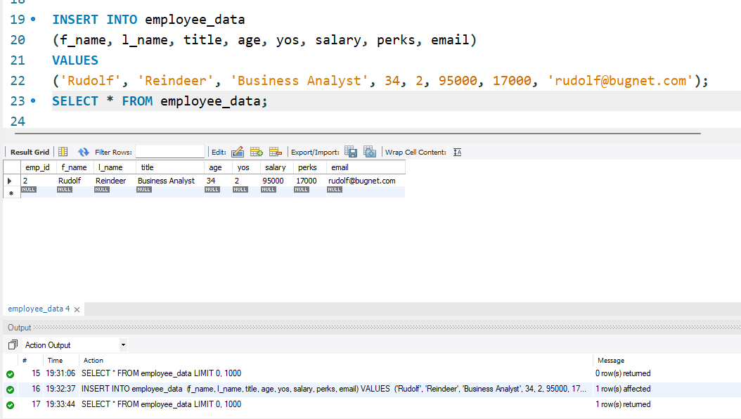

6. What will select f_name, email from employee_data; display?
SELECT f_name, email FROM employee_data;
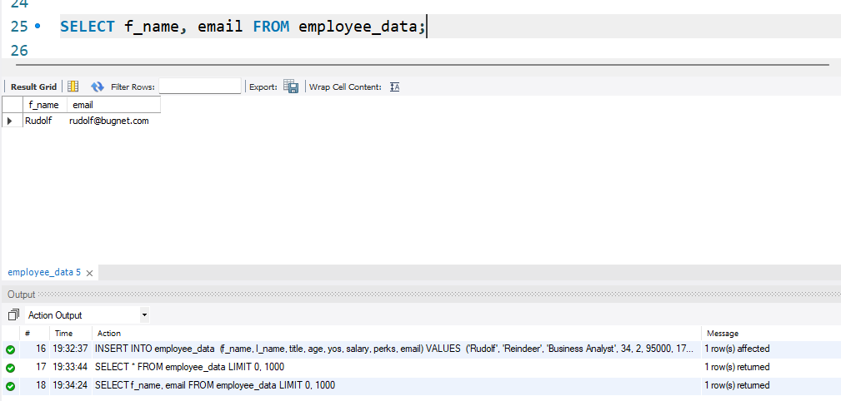

7. Write the statement for listing data from salary, perks and yos columns of employee_data table.
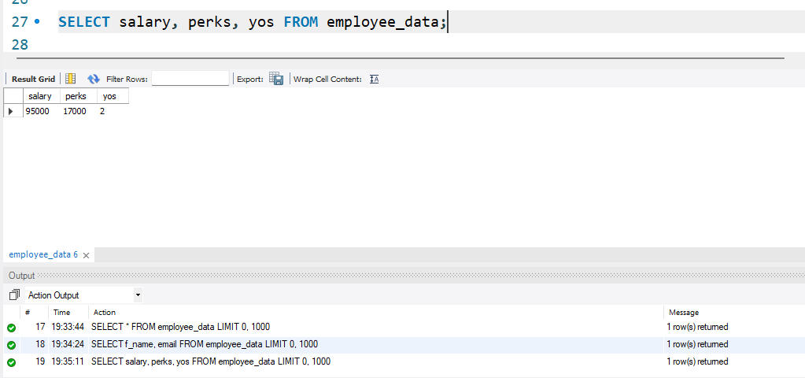

8. How can you find the number of rows in a table using the SELECT statement?
SELECT COUNT(*) FROM employee_data;
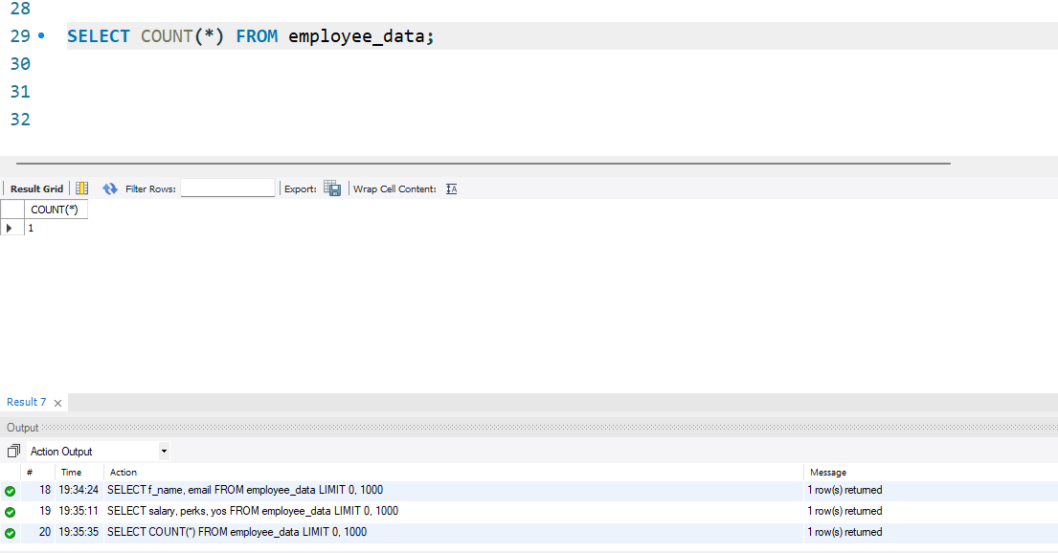

9. What will select salary, l_name from employee_data; display?
